Parent/Guardian/Student Copy

_____________________________is

in _________grade.

Please read this handbook and review the contents with your child. Both the student’s signature and yours should be signed twice. One will remain with this planner as a record for you, and the other will be removed by the teacher for the school.

If you have any questions, please do not hesitate to call the school.

I have received and reviewed the 2020-2021 Student Handbook with this student.

____________________ ______________
Student signature Date signed

___________________ _________________
Parent/Guardian signature Date signed

Parent/Guardian/Student Copy

School Copy

_____________________________is

in _________grade.

Please read this handbook and review the contents with your child. Both the student’s signature and yours should be signed twice. One will remain with this planner as a record for you, and the other will be removed by the teacher for the school.

If you have any questions, please do not hesitate to call the school.

I have received and reviewed the 2020-2021 Student Handbook with this student.

____________________ ______________
Student signature Date signed

_______________________ __________________ Parent/Guardian signature Date signed

School Copy

Laconia Middle School
Student Handbook
2020-2021

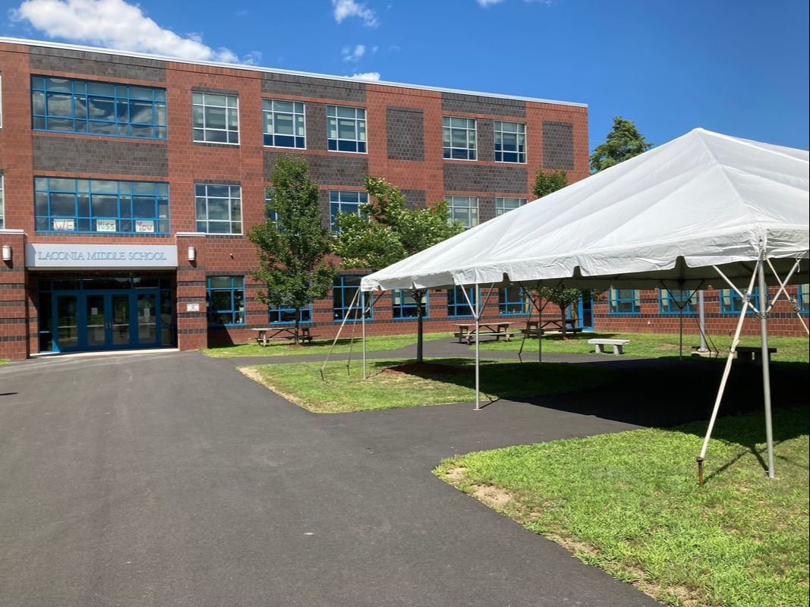

Introduction
September 2020

Dear Students and Families:

We are excited to welcome you to the 2020-2021 school year! We hope that your summer has offered plenty of opportunities for relaxation and fun. Specifically, we hope that you have enjoyed the beauty of our community during these summer months.

As we enter this school year, our focus will be on reconnecting with our students in person, when possible, and remotely with our students in the remote division. We recognize that spring was filled with unexpected challenges, both academically and social/emotionally. We are prepared to support our students through this unique transition into the new school year.

Please take some time to read through this handbook and learn more about our schoolwide expectations, important policies, and information about program offerings. It is important that students and families understand the information in the pages that follow. Please note that there may be some changes to course and extracurricular offerings as we transition back this year.

Middle school is an exciting time filled with tremendous growth and new opportunities. At Laconia Middle School, we believe that all students are capable learners and important community members. We look forward to our journey together this year, and we are here to support your child. We believe in our district’s mission: ensuring success with every student, every day, in every way. Please do not hesitate to contact us if you have any questions or concerns.

Sincerely,

Dr. Alison Bryant, Principal

School Overview

School History and Profile
Laconia Middle School has been a symbol of the collaborative efforts of the city and the school district since its inception. In January 2006, a new building project to replace Memorial Middle School began, and in 2009, Laconia Middle School was complete. One of the greatest functions of the new building is its access to the natural beauty that surrounds the school. For example, students have a stunning view of Lake Opechee from the school cafeteria.

Our collaborative efforts with the city continue to be at the heart of our mission at Laconia Middle School. Our beautiful building is inviting to all learners, and we are proud hosts to school, district, and community events all year long.

Laconia Middle School serves students approximately 480 students in grades 6-8. All students participate in rigorous core academic and exploratory classes. We offer a broad variety of extracurricular activities where students have unique opportunities to further develop skills and build relationships within our school community.

Portrait of a Graduate
The Laconia School District’s Portrait of a Graduate ensures that all Laconia students will be able to effectively, communicate, collaborate, create, persevere, problem-solve, and self-direct. We continue to provide instruction that focuses on developing these traits.

Vision & Mission Statements
The Laconia Middle School’s vision is to develop informed decision makers who are academically prepared for lifelong learning.

Our mission is to Engage, Prepare, Inspire, and Challenge all students.

STAFF

Administrative Team: Dr. Alison Bryant- Principal
Mr. Chrigus Boezeman – Assist. Principal/AD
Ms. Angel Burke- Academic Coordinator
Mrs. Jennifer Sottak – Student Services

Secretaries: Mrs. Dawn Emond
Mrs. Katie Whitney

TEACHERS

6th Grade
Name Room Subject

Team Discovery
Mrs. Whitney McCallum 125 LA & Social Studies
Mrs. Sonya Roberts 123 Math & Science
Mrs. Debra Matsumoto 117 Special Education

Team Opportunity
Mrs. Kelsea Doucet 122 Math & Science
Mrs. Amanda Youssef 124 LA & Social Studies
Mrs. Debra Matsumoto 117 Special Education

Team Enterprise
Mrs. Ann Peterson 103 Math & Science
Mrs. Deborah Tivey 101 LA & Social Studies
Ms. Joanna Bergman 104 Math & Science
Mr. Nick Resca 105 Special Education

7th Grade
Maple Team
Mrs. Martha Jane Connelly 203 Science
Ms. Cathy Baylus 204 Social Studies
Ms. Abigail Ball 201 Math
Mrs. Rebecca Sims 202 Language Arts
Mrs. Taylor Jenkins 205 Special Education

Oak Team
Ms. Tara Columb 225 Language Arts
Mr. Jim Carmody 222 Social Studies
Mrs. Susan Oehlschlaeger-Hildreth 223 Science
Mr. Kevin Bisson 224 Math
Ms. Karen Muthersbaugh 217 Special Education

8th Grade
Team Winnisquam
Mrs. Leanne Keller 323 Science
Ms. Lindsay Middleton 322 Language Arts
Mr. Derek Pabst 324 Math
Ms. Lauren Krainchich 325 Social Studies
Mrs. Jayme Duggan 317 Special Education

Team Opechee
Mrs. Jessica Rominger 303 Science
Ms. Shannon Siegler 302 Language Arts
Mr. Chris Carey 301 Math
Ms. Stephanie Atherton 305 Social Studies
Mrs. Carrie Duhamel Special Education

World Languages
Mrs. Anita Fair 240 6-7-8

Physical Education
Mr. Joseph DiTommaso 186 6-7-8
Ms. Lindsy Poulin 188 6-7-8

Music
Mr. Nathan Wotton 166 6-7-8
Band - TBD 167 6-7-8

Art
Mrs. Sharon Frick 333 6-7-8

Health
Mrs. Carolyn Muniz 241 6-7-8

Behavior Interventionist
Ms. Anna Solomon 6-7-8

Paraeducators
Ms. Erin Davis, Mrs. Paula Fernandez, Mrs. Deb Williams, Mr. Tom Fish, Ms. Paula Medeiros, Mrs. Barbara Chapman, Mrs. Brittany Hilliard, Mr. Josh Emond, Mr. Kaleb Orton, Ms. Aja Montague, Ms. Meya Minor

Guidance Counselors
Mrs. Rebecca Noe 153 Grades 6/7
Mr. Greg Schneberger 151 Grades 6/8

Social Worker
Ms. Melissa Pacini 159 6-7-8

School Nurse
Mrs. Davlyn Wholley 127 6-7-8

School Library
Mrs. Angela Vaillancourt 232 Library Media Teacher

Psychological Services
Mrs. Christine Flanders 156 6-7-8

Speech
Ms. Megan Morey 217 6-7-8

ESOL Grade 6-8
Chris Beyers 305B 6-7-8

Custodial Staff
Bill Caruso, Paul O’Brien, Jeff Haven, Allen Vincente, Shannon O’Hara

Cafeteria Staff
Manager- Dianne Ouellette. Anne Flanagan, Imsuk Contois, Betzy Weller, Penny St. Cyr, Debra White

General Procedural Information
Backpacks and Bags
Backpacks and bags may be used to bring materials to and from school. Backpacks and bags do not travel from classroom to classroom with students; they are to remain in student lockers during the day. During our opening month of this school year, backpacks may be left in the classroom. This will be at the direction of the teacher.

Lockers
Lockers are issued during the school year for the convenience of students. The lockers are for the use of one student per locker only and remain the property of the Laconia School District. They are subject to inspection by the administration upon a reasonable suspicion.

Students are subject to a $8.00 charge for all lost or stolen locks. Personal locks must be approved by administration. It is the student’s responsibility to lock their locker and not give out the combination to anyone. Security of items in the locker are the responsibility of the students. Students are responsible for reporting broken locks or lockers. Administration reserves the right to cut off locks that are not registered with the office.

Passes
Other than during passing times, students will have a written, signed pass indicating destination when they are not in class.

Lost & Found
Any clothing article found should be placed in lost and found. Clothing items in lost and found will be disposed of during vacation weeks. Books, jewelry, or electronic devices should be turned into the administrative offices. These items will be recycled at the end of July.

Pledge to the flag
As per NH state statute section 194:15-c LMS offers a time every morning for the Pledge of Allegiance salute to the flag. The statute states students who do not wish to participate must either stand silently or sit silently during this time.

Animals
Students are not allowed to bring animals of any kind to school without prior consent by the building principal.

Fundraising
If a club, group, or team require additional funds and wish to hold a fundraiser this must be approved by the building principal.

Student Usage of School Phones
Students may only use a school phone with permission from a staff member and only when necessary. There is a phone for student use located in the guidance office. Students should not use any other school phones unless directed to do so by a staff member.

Parent-Teacher Conferences

Communication between teachers and parents is a key component for student academic success. Parents who wish to discuss concerns regarding their child’s academic progress can arrange for a conference by calling guidance (524-4632) and setting up an appointment. Parent-Teacher conferences will be held in November.

Student Records

Information regarding the maintenance, review, and release of student records can be obtained by contacting the guidance department.

Video Cameras

Students and parents are reminded that video camera surveillance is used throughout LMS as well as on school buses. School safety is enhanced through the use of video. Cameras are positioned in hallways, exterior doors and the parking areas.

Withdrawal from School
Parents and Students who plan to transfer from Laconia Middle School to another school should make their request to the guidance office as soon as possible. Students who are leaving must make sure that their lockers are clean, and all books and materials should be turned in to their respective teachers. If materials are not returned parents/guardian may be charged the cost of those materials. The day the student is to leave, he/she should pick up the withdrawal form in the office.

Change of Address
Parents must report any change of address or telephone numbers to the school as soon as possible.

Visitors or Appointments
For the safety of students and staff, all visitors must check in at the window in the front entrance upon entering the building. All visitors will be required to wear a visitor’s pass. Visitors are expected to call ahead to set up an appointment with the person they wish to visit; without an appointment, the person that you wish to visit may not be available. As we begin this particular school year, no visitors will be permitted in the building without prior administrative approval.

Sign-in/Sign-out

All students arriving to school between 7:57 and 2:21 must sign in. If a student is late he/she should have a note explaining why. The arrival time and the reason for being late must be stated on the sign-in list. A late pass will be issued by the office.

Signing-Out- All students leaving school from the time they arrive to 2:21 must be checked out by a parent in the office. Students being dismissed should have a note from home in order to be prepared for checking out. It is our recommendation that medical/dental orthodontic appointments be scheduled during non-school hours whenever possible. If returning before the end of the school day, the student is to sign in and receive a hall pass before returning to the classroom.

There are two other options for dismissing your child:
- You can designate another person to pick up your child on the file update form that is sent home in the packet of forms on the first day of school.
- You can call the school and let us know that the child has permission to walk home or you are sending a taxi to pick your child up at school.

It will be a parent/guardian's responsibility to come to the main office to release a student before dismissal.

Arrival and Dismissal

Arrival
1. Students are to arrive no earlier than 7:30 a.m.
2. All students arriving to school must go to their designated area in the morning.
3. Student drop off by automobile is located in the parking lot parent drop off area. Only buses are permitted in the bus lane during drop off and pick up.
4. Only those having a pass will be allowed into the academic wing of the building.
5. Once you are within sight of the school you must come onto school grounds and you may not leave.

6. Students who ride bicycles to school must park them in racks immediately upon arriving at school. All bicycles should be secured with a chain and lock. Any bicycle locked to something other than the bike rack may be subject to having the lock cut off. Students must leave bicycles belonging to other students alone. Bicyclists should arrive/exit school property by walking their bikes. The school cannot be responsible for bicycles/scooters/skateboards brought to school.
7. As soon as students have entered school, all doors will be locked for safety and security. Late arrivals must report to the office for a pass.
8. Skateboards, scooters, bikes, rollerblades, etc. may not be used upon reaching school grounds. These items may be left in the main office or your homeroom teacher.

Afternoon Dismissals
1. Students will be dismissed at 2:21 p.m. Earlier dismissals must be approved by authorized staff.
2. It is imperative that parents pick up students right after school to avoid loitering.
3. Students participating in after school activities will go to the designated area promptly and not exit and re-enter the building.
4. Re-entry will be allowed only for legitimate reasons.
5. Any infractions will be reported to administration and may result in consequences

Students must be picked up promptly - Students staying after school for activities or homework help should be picked up promptly. All students staying after school must be with a teacher or coach. “Hanging out” or wandering the building and school property is not permitted. Students waiting for pick-up after 2:50 should report to the office and call for transportation.

School Expectations

School Dances

ONLY Laconia Middle School students are allowed at dances unless administration pre-approves a student from a different school.

- Students who receive a Major Behavior Referral resulting in administrative disciplinary action on the week of the dance will not be allowed to attend the dance.
*** A Major Behavior Referral is a form sent to the Assistant Principal to address problematic student behavior.
- The time period for behavior is two weeks for the semiformal dance.
- DRESS CODE: The school dress code applies. Hats may or may not be appropriate. Administration will let students know in advance if hats can be worn.
- Dance pick-up: Any student remaining 15 minutes past the end of the dance will not be allowed to the next dance.
Dances are from 6:00-8:00

Field Trips
During the school year teachers may plan to take their classes on educational field trips. The right to participate is based upon the following factors:
1) Parental permission forms are received on date designated by teacher. Only students with a parent or guardian signature will be allowed on the field trip (faxes are acceptable)
2) Student is in good standing in his/her classes.
3) Students who have missed excessive amounts of school of any kind may not be able to participate in a field trip. Students who have exhibited poor school behavior may be refused the opportunity to go on a field trip.

8th Grade Class Day Activities
Class Day activities have included a picnic, ceremony, reception and dance. Eighth-grade students not going to high school or those who have academic, attendance and/or disciplinary violations may not earn the privilege of participation in the end of the year 8th grade activities. Warning of possible non-participation in the 8th grade dance will be made during the fourth quarter.

It is our wish that students be neatly dressed and groomed for their class promotion night. We expect boys to wear a shirt, tie, and a pair of appropriate pants and girls to wear pants or a skirt and blouse, or dress.

INTERNET USE

All student Internet users will be introduced to the proper protocol regarding electronic communication during classroom instruction.

This includes:
1. Respect for privacy
2. Dissemination of personal information
3. Confidentiality of information and passwords
4. Use of appropriate language
5. Use of appropriate sites; sites with violent themes or content, sexually explicit themes or content,
sites that advocate hatred, intolerance or contain language unsuitable for a school setting are not
appropriate
6. Proper adherence to applicable copyright laws
7. Reasonable limitations of file space use

Parental Permission for Internet Use
Parents will sign the Internet Use form when their student enters the Laconia School District. The permission form will be kept in the student’s record folder.

At the start of each school year a list of students not permitted to use the Internet in the school setting will be generated and distributed to appropriate faculty and staff. These lists will be updated as needed.

Procedures for Internet Use
The District will actively maintain and update filtering software to regulate appropriate use of the Internet.
Instructors and staff members are responsible for monitoring student use of the Internet, which will be consistent with the District’s educational mission. However, the responsibility for proper use of the Internet as outlined in this procedure rests with each student.

Any student that accidentally accesses inappropriate materials is to immediately notify the staff member in charge. If a student has any question about a site, the student has an obligation to ask the staff member in charge whether the site can be accessed. Chat rooms or similar sites are not to be accessed.

Computer ‘hacking’ in all forms is prohibited. District technology equipment is not to be used to gain
unauthorized access to other computers, networks or technology systems. Anyone attempting to gain
unauthorized access to the District’s computer systems or network(s) may be subject to legal prosecution.

Students or their parents are liable for damage to the District’s technology resources including all equipment, media and the District network. They are liable for vandalism, theft or destruction as well as any violation of copyright laws committed while using District technology resources. They are likewise liable for any damage caused to remote equipment from unauthorized access, willful misuse or ‘hacking’.

Consequences for Misuse of the Internet
Each building administrator will develop and publish the disciplinary actions related to misuse of technology
Consequences:
First Offense: The first consequence may result in up to one quarter suspension of computer use as well as any other consequences in accordance with the school discipline policy. (This includes possible replacement of damaged software or hardware.)
Second Offense: May result in loss of computer use for one full year as well as any other consequences in accordance with the school discipline policy.

Copyright:
There are specific laws regarding the use or copying of information. This includes copying pictures/symbols or information from textbooks, internet, television, or other information avenue. If there comes a question regarding copyright information, please refer to your teacher or the school librarian for clarification.

School Attendance
Attendance patterns are formed early in life. Children who develop good attendance habits in the early grades will be more likely to continue them throughout their school careers. Parents who make regular school attendance a priority are also helping their children learn to accept responsibility and to work towards achieving their full potential. We believe in each of our student’s ability to be a contributing and outstanding member of our school community. Being in school and on time regularly are important aspects of this.
Truancy is any absence that is not excused. Students who skip school are in violation of RSA l93: l School Attendance Law. The law states that every child between 6 and l8 years of age shall attend public school. RSA l93:2 Duty of custodian: Every person having the custody of a child shall cause the child to attend school.
Absences From School: We ask that if a child is going to be absent from school, a parent or guardian calls the school to inform us. We appreciate if all efforts are made to inform the school of this absence by 7:57 am. Students who are absent from school are not permitted to attend school-related functions that day/evening.
- Excused Absences -We understand that there are times when a child must be out of school. We see these as excused absences, and include illness, death in the family, religious holiday, family emergencies, and family vacations.
PLEASE NOTE: After 10 or more EXCUSED absences, administration/guidance may request documentation to substantiate a student’s absence.
- Unexcused Absences -Each day of school is filled with academic progress and personal and social growth. We would not want any student to miss out on this unless absolutely necessary. There are some reasons that students stay home which are not considered excusable by the school. Some examples of this include staying home to baby-sit, oversleeping, being tired, shopping, and birthdays. These absences will be considered as truant by the school.

School Functions
During the school year, Laconia School District sponsors many after school events. This includes, but not limited to Homecoming Activities, Winter Carnival, athletic contests, band performances and school dances. If a student has been absent from school, he/she will not be permitted to attend or participate in any school function that day or evening (including any weekend activities if the absence occurred on a Friday) unless prior permission has been granted by the administration. Students who earn an In School or Out of School Suspension on the day of an event, will not be permitted to attend any after school event, either on or off school grounds.
Tardiness: We encourage all of our students to arrive at school by 7:45 am. By doing so, they have time to settle in, socialize with peers, and finish up any needed work. Tardiness occurs when a student is not in class at 7:57 am. We believe in teaching our students important habits which can be carried on throughout their lives. This includes the value of being on time. When students are late, the child is unsure of what to do in a classroom where everyone else has begun to work. We do not want any child to start his/her day feeling uncomfortable because they entered a classroom late. A tardy will be considered excused if it is for an appointment or other pre-approved reason. All other tardies will be considered unexcused unless other arrangements have been made with the school. This is so that the school has a full understanding of the amount of time missed by the student. As with absenteeism if you are having a hard time getting your child to school on time, please discuss this issue with the school so that we can work together to resolve the issue.
Chronic Absenteeism: We want to support every child as a student and member of our school community. This can be hindered by a student being continually, or chronically, absent. If a student begins to display chronic absenteeism, the school will take every step possible to assist the family in having the child in school more often. If this assistance does not lead to improved school attendance, the school may have to take appropriate legal steps in order to help the child be a regular attendee and a successful student. NH RSA 193:1 does state that a parent of any child at least 6 years of age and under age 18 shall cause such child to attend the public school to which the child is assigned in the child’s resident district. If you need assistance in getting your child to school, please speak with your child’s teacher, school counselor or a school administrator. Sometimes, barriers to attending school exist that the school is not aware of. Please work together with the school to overcome these barriers as we are here to partner with each family to help our students achieve to the best of their abilities.
Family Vacations Traveling with family can be a rewarding and educational experience for children. When a child spends excessive time away from school because of family travel, they are missing important classroom instruction and socialization that cannot be made up. We encourage families to travel within the given school vacation times. If family vacation time must absolutely be taken during school days, please inform the school so that the teacher can best prepare the student.
Absences/Tardiness – School Monitoring
The school will monitor the attendance of all students. When a student is continually absent and/or tardy, the following procedure(s) will take place per policy JH School Attendance/Absenteeism/Tardies
- When a student is absent 10 or more half (1/2) days during the school year a letter will be sent home to inform the parents of the number of days the child has been absent and to aid the family.
- If the student continues to be absent and/or tardy, the school will contact the parent/guardian to discuss the issue and what can be done to resolve it. We will ask for a parent/guardian to participate in a school meeting to have a more in-depth discussion.

3. Students who exhibit chronic absenteeism (falling below 80% daily attendance) may be referred to the Department of Child, Youth and Family Services (DCYF).

Students who are habitually truant for 10 half days of unexcused absence during the school year will also receive a letter. “Truancy” means an unexcused absence from school and “unexcused absence” is an absence which has not been excused in accordance with RSA 189:35-a.

The school will make every effort to work with the family to support their child in getting to school each day.

School Functions
During the school year, Laconia School District sponsors many after school events. This includes, but not limited to Homecoming Activities, Winter Carnival, athletic contests, band performances and school dances. If a student has been absent from school, he/she will not be permitted to attend or participate in any school function that day or evening (including any weekend activities if the absence occurred on a Friday) unless prior permission has been granted by the administration. Students who earn an In School or Out of School Suspension on the day of an event, will not be permitted to attend any after school event, either on or off school grounds.

SCHOOL SERVICES

Insurance
Laconia Middle School students are eligible to participate in either of two accident insurance plans:
a) coverage while attending school, and while traveling to and from school, or
b) a 24-hour plan
Forms will be sent home at the beginning of the school year with complete information concerning our insurance program, provided by a local agency for a low premium.

Psychological Services
The middle school has a psychologist that is available on a part-time basis.

Health Services
- The school nurse is in attendance throughout the school day. If a student does not feel well or has an accident, he/she should report to the teacher in charge then given a pass to the nurse's office.
- Any student with an assistive device of any type such as crutches or cast, who has been out for a significant illness, medical emergency or extended period of time, will check in with the nurse upon returning to school.
- Students are dismissed when necessary by the nurse. When the nurse is not available, the principal or her chosen designee will contact the student’s family; transportation is the responsibility of the parents.
- In case of emergencies when parents cannot be contacted yet immediate treatment is needed, the emergency contact is called, and necessary treatment is delivered if approved. When necessary, an ambulance will be called if other means of transportation are either not available or would be considered potentially aggravating to the existing illness or injury.
- If student participation in school is limited due to health reasons a parent or guardian should contact the school nurse. Inability to attend school over an extended period (3 days) will require a written note from a medical provider.

IT IS CRITICAL THAT EMERGENCY INFORMATION FORMS ARE UPDATED throughout the year!!!!

Out of State Transfer
According to the New Hampshire Law RSA200:22-200:38, a student entering the New Hampshire public school system from another state is required to have a physical examination upon entrance or to have certification of the completion of a physical exam within a year prior to entrance.

Immunizations
According to the New Hampshire Code of Administrative Rule HeP301.13(4)c: “Acceptable levels of immunization for school entrance shall be in accordance with the New Hampshire 2016/2017 School immunization Requirements.

Children 11 years and older prior to entering 6th grade are required to have a one-time TDaP Booster immunization prior to the start of the school year.

According to New Hampshire Administrative Rule He-P301.15: “A child may be admitted under ‘conditional enrollment’ with documentation of at least one dose of each required vaccine. The parent or guardian shall also provide an appointment date for the next due dose of DTP/DT/Td/TDaP/TOPV, from a health care provider. This appointment date shall serve as their suspension date if they fail to keep the scheduled appointment.” (pg. 22)
SAU Policy JLCD

ADMINISTERING MEDICINES TO STUDENTS

Whenever a student has health needs which require taking medication during the school day, the school nurse shall be responsible for establishing specific procedures to protect and control medication administered in schools. If at all possible, prescribed medication should be taken at home.

1. Prescribed medication, properly labeled and accompanied by a written statement from the prescribing physician detailing the name of the medication, dosage and time schedule to be observed, will be given by school nurse or administration. A permission to administer form must be signed by a parent or guardian prior to the administration of medication. Forms may be obtained at the nurse's office in the middle school. Medication will not be administered without the required form signed by the parent.

2. Student medications must be brought to and from school by a parent or guardian. Students are not allowed to bring their own medications to the school nurse.

3. The school cannot administer medication that is labeled for another person.

4. A limited supply of over the counter medications is available for students. A signed over the counter medication authorization permission by a parent or guardian prior to the administration of these medications is required by state law each school year.
5. A pupil may possess and self-administer an emergency rescue inhaler to alleviate or prevent asthmatic reactions, auto-injectors for severe allergic reactions, and other injectable medications such as insulin, if authorized in writing by both the student’s physician and parent/legal guardian. The parent/ guardian must provide written proof of the prescription along with verification that the student has the knowledge, skills, and ability to safely possess and use the medication in a school setting.

Students shall not share any prescription or over the counter medication with another student. Each year, the District shall notify students in writing of this prohibition and the violations shall result in appropriate disciplinary action, including but not limited to suspension or expulsion.

Care Closet
The Care Closet is a school based, community supported service that is facilitated by school faculty and caring school families. The Closet offers academic supplies, clothing and hygiene items to families in need. The Closet is stocked through the generous donations from our school’s faculty, staff, and families as well community members and businesses. The maintenance of the Closet is through the hands of many kind volunteers. Families in need can speak with guidance or the school nurse to be connected with essential items and resources.

Guidance and Counseling Services
Students will be assigned to one of the following guidance counselors:

Mrs. Rebecca Noe - Grade 6/7
Mr. Greg Schneberger - Grade 6/8

The purpose of the guidance program is to assist and encourage each individual toward becoming a self-directed and responsible person. Guidance counselors will:
- assist students in fulfilling their educational requirements and needs
- interpret information for the students which will help them acquire a greater self-understanding
- assist each student in resolving any special personal problems that arise (family, peer, school, etc.)
- act as a sounding board for students who want to talk, giving them a moment of friendly time and attention
- serve as an additional supportive school person.
- counsel for any reason that is important to the student.
- provide group guidance.

Transportation

Bus Transportation

Bus transportation is furnished for students who live beyond a 1 ½ mile radius from the school. Bus schedules are posted in the newspapers prior to the start of school each year. Questions regarding location of bus stops and bus routes can be directed at First Student (524-1787). Bus expectations will be made clear to students on each bus. Bus rules are posted on each bus. Buses may be videotaping occupants at any time.
Students in violation will be referred to administration of the attending school. Consequences may include loss of bus privileges. Appeals may be made to the SAU office.

Academic Information

In compliance with the provisions of the Title IX, all educational courses and activities are open to all students.

The selection of teams will be done by administration only for the purpose of creating a well-balanced school.

Grade 6-8
The following subjects are scheduled regularly throughout the year: English, Math, Social Studies, and Science. Students in grades 6-8 will participate in Exploratory classes as their schedule permits. Students will not receive all exploratory courses in a given year.

Math program of studies

In Grade 6 the focus is on:
- connecting ratio and rate to whole number multiplication and division
- using concepts of ratio and rate to solve problems
- completing understanding of division of fractions
- extending the notion of number to the system of rational numbers, which includes negative numbers
- writing, interpreting, and using expressions and equations
- developing understanding of statistical thinking
In Grade 7 the focus is on:
- developing understanding of and applying proportional relationships
- developing understanding of operations with rational numbers
- working with expressions and linear equations
- solving problems involving scale drawings and informal geometric constructions
- working with two- and three-dimensional shapes to solve problems involving area, surface area, and volume
- drawing inferences about populations based on samples
In Grade 8 the focus is on:
- formulating and reasoning about expressions and equations
- modeling an association in bivariate data with a linear equation
- solving linear equations and systems of linear equations
- grasping the concept of a function and using functions to describe quantitative relationships
- analyzing two- and three-dimensional space and figures using distance, angle, similarity, and congruence
- understanding and applying the Pythagorean Theorem
Some students in 8th grade will take Algebra 1A. Topics include:
- Foundations for Algebra
- Equations and Inequalities
- Linear and Nonlinear Functions
- Organization and Analysis of Data
- Systems of Equations and Inequalities

Language Arts program of studies
Language Arts provides a core understanding of reading, writing, vocabulary acquisition, speaking, and listening skills. Students receive a wide range of instruction to challenge, enhance and enrich their learning. The standards of English are used to communicate effectively for multiple audiences. Students learn strategies for lifelong learning to help them understand and problem solve. A variety of before, during, and after methods of instruction are used to aid and assess student readiness and mastery. The key ideas of learning are through the integration of a variety of genres with a wide range of reading and writing that includes technology.

Science program of studies
The LMS science department continues to refine, design and implement a scientific education that helps students develop an appreciation, excitement and intellectual awareness of the natural and human-made world. Students learn how to function effectively in an increasingly complex, and technological planet within a nurturing and challenging classroom environment. Our vertical model teaches physical science in 6th grade, life sciences in 7th grade, and Earth sciences in 8th grade. The skills of the scientific inquiry and reporting are taught each year.

Social Studies program of studies
In the sixth grade, the subject is ancient and medieval history of Western Civilization from Mesopotamia and Egypt to the Renaissance. In the seventh and eighth grades, the subject is a two-year course in United States History that overlaps in the Reconstruction Period. Other disciplines included in Social Studies are integrated into these courses as appropriate: local and state history, geography, economics, and civics. There are mandatory expository and literary writing assignments that are aligned to content and are consistent in format to allow students to excel in knowledge and skill.

Exploratory Courses

General Music
At the sixth-grade level, students are introduced to the music of the Middle Ages, Renaissance, Baroque, Classical, Romantic, Impressionistic, and 20th Century music periods. Listening is emphasized, with 2-3 examples analyzed from each period. Treble clef note reading and simple rhythmic concepts are reviewed, extending from whole notes and rests to eighth notes and eighth rests. In 7th grade music, students learn about world cultures and drumming traditions. They will play various African and Caribbean instruments, compose their own ensembles, and learn how to dictate complex rhythmic patterns. In 8th grade music, students learn about popular 20th century American music, how the music industry functions as a business, and how both have evolved over the decades. They will also learn guitar fundamentals including chords and single note songs.

Band
Any student possessing instrumental ability, or interest, is urged to join the band. This course will further develop the student's musical abilities and experiences through regular rehearsal. Mandatory events include three concerts, a Halloween parade, a tour of the elementary schools (6th grade only), and eighth grade promotion. Additional, optional performances include Solo & Ensemble Festival, Lakes Region Music Festival (7th/8th grade only), and Great East Festival and Six Flags (7th/8th grade only). If you do not currently play an instrument, but would like to learn, we can assist in setting up lessons for you until you are ready to join the full group. Daily practice is encouraged and expected.

Chorus
This course is offered to any students who would like to participate in it. The ability to read music is not necessary. Throughout the year, members will gain knowledge in the areas of music reading and vocal production. The chorus performs in many events, including concerts and assemblies. There are many opportunities to perform outside of school also, such as state and regional music festivals. All chorus members will be required to participate in four concerts during the school year which is included in determining the final grade. Chorus will have an impact on a student’s ability to participate in exploratory classes.

Students may be ineligible to attend band and chorus field trips based on behavior concerns.

World Languages
World Languages is an introduction to the French and Spanish languages and cultures. The fundamentals of French and Spanish pronunciation, grammar, and culture are presented through a balanced development of all four skills: listening, speaking, reading, and writing. The importance of communication and cultural awareness is stressed through a wide variety of activities (group/pair work, video, audio recordings, computer assignments, etc.)

Foundations of Art
Foundations of Art in grades 6-7-8 is designed as an introduction to art for the middle school student to art. Students will gain hands-on experience with a wide variety of art mediums. These include drawing, collage, color theory, printmaking, ceramics, painting and art history. Students will create unique and original works of art both individually and collaboratively. Through the exploration of art in different cultures, the elements and principles of design, art production, aesthetics, and art history, students will be presented with an all-inclusive approach to art.
The main objective of Foundations of Art 6-7-8 is to solve problems in the creation of visual products. For more information and student art work please refer to Mrs. Frick’s Visual Art Class website link that appears on the home page of the LMS website.

Physical Education
PE is an important part of promoting lifelong good health. Students assigned PE class are expected to wear proper dress (gym sneakers, t-shirt, sweatpants or shorts), and they are expected to maintain a clean locker that they keep locked at all times.
Students unable to participate must have a note from parents. Those students missing more than 5 classes require a doctor’s note presented to the school nurse.

ONLY STUDENTS IN PE OR ON ATHLETIC TEAMS ARE ALLOWED IN THE LOCKER ROOM.
ALL STUDENTS MUST BE ACCOMPANIED BY A SUPERVISING ADULT.

Health
The purpose of health class is to teach students to make informed decisions for a lifetime of fitness and wellness, improve their performance at school and sports, the way they interact with each other and the way they feel about themselves. Students learn through a variety of methods including incorporating adventure activities and technology. Topics covered include: teambuilding and developing community, violence prevention, safety, substance abuse, healthy eating and physical fitness, mental and emotional health, human growth and development, disease prevention, friendships and food preparation.

Promotion
Promotion at Laconia Middle School is earned by passing grades. This includes Exploratory classes, Remediation/Enrichment (R.E.) period and World Language. Students who are not promoted may still have the option of being placed in the next class.

Cheating/Plagiarism
Plagiarism is an act or instance of using or closely imitating the language and thoughts of another author without giving credit or identifying the work as your own. Cheating includes copying the work of another student or utilizing unauthorized sources, such as notes, during an assignment or assessment.

Students who plagiarize or cheat on an assignment will be required to redo the assignment under the supervision of an adult. A phone call will be made to parents by the teacher and administration will be notified. Additional offenses will be dealt with in a progressive discipline manner.

REPORTING POLICY
Report cards are issued every quarter (9 weeks). In addition, Progress Reports will be given to students halfway through each quarter. (See LMS calendar, back cover of agenda book for specific dates). Numerical grades will be given for all academic, exploratories, and world language classes.
Parents and students may access student’s grades using ALMA which can be accessed from the school’s webpage. Please call the guidance office for the student or parent password.

Progress Reports will be issued for all students. Progress Reports and Report Card will be available electronically. Hard copies will be mailed to parents/guardians who do not have access to Alma or email.

The grades on report cards are given numerically which may be translated as follows:
93-100 = A 73-76 = C
90-92 = A- 70-72 = C-
87-89 = B+ 67-69 = D+
83-86 = B 63-66 = D
80-82 = B- 60-65 = D-
77-79 = C+ 59-Lower = F
INC= Less than a 55 and/or missing large quantities of work Incompletes

A student will normally be given a period of two weeks from the time of the closing of the marking term to make up any work in a course that he/she received an incomplete. If he/she does not make up this work, he/she may fail the subject.

ACADEMIC RECOGNITION POLICY
High Honor Roll shall be composed of students who earn A's in all courses.
Honor Roll shall be composed of students who earn A's and B's in all courses.

STUDY HABITS

Homework
The purpose of homework is to provide students with meaningful opportunities to extend their learning and practice important academic skills. Sixth, seventh and eighth grade teachers may be assigning daily homework which will not exceed 20 minutes per night (grade 6), 25 minutes per night (grade 7), and 30 minutes per night (grade 8.) Unless a student is falling behind, homework generally will not be assigned on Fridays.

Homework will be new to many of the 6th grade students, and their success will depend on how well they organize themselves when they prepare to do the work. Parents can help by developing expectations for homework completion, including a time and place for students to work.

Good Study Habits
- Record assignments in your student planner.
- Take home necessary study material - assignments, books, etc.
- Set up a definite study time and adhere to it. After supper can be a good time for most young people.
- Have a quiet study area free of distraction, radio, TV or other noises.
- Prepare the next day's assignment thoroughly so you are ready for discussion, reports, and written tests or quizzes.
- Studies have shown that parent involvement in their child’s schoolwork leads to greater success. When students are accountable at home, student achievement will improve.
- Go into the classroom with the intent to:
a) pay attention to what is going on
b) do your best
c) be prepared
8. Check grades regularly on Alma. Please contact your guidance counselor for access information or assistance.
Students missing work for sickness, field trips, vacations, suspensions, etc. are expected to contact the teacher upon returning to school for makeup help in a timely fashion. Students are allotted 2 days to make up work for each day they are out.
A request for homework may be made by a parent. This could be picked up in the main office the following school day.

Extra Help
Students should seek extra help from teachers when they have missed classes or failed to understand class work. This effort will do much to help assure success in class. There is a time for students to seek help both before and after school. Each team has created a schedule of after school support that ensures availability of support on Mon/Tues/Thurs. each week. Teachers are also available at other times by appointment. If your child is struggling, do not hesitate to set up a conference so supports can be put in place to help your child’s academic progress.

Make-Up of School Work
Teachers and teams will provide time on Mondays, Tuesdays, and Thursdays for students to access extra help and to make up missed work. Each teacher will notify students of their make-up schedule time. Students returning from suspension will be given the opportunity to make up their work.

School Library
The library is an instructional materials center that contains books, magazines, newspapers, pamphlets, computers, and a variety of audiovisual materials. It will be used by students and teachers for the purpose of researching print material as well as online material, studying, and recreational reading.
- Books are checked out for a two-week period with renewal privileges except for books highly in demand.
- Audio-visual items may be checked out to teachers only, but may be used by students in the classroom.
- Students are strongly urged to return all books promptly when due in order to retain checking out privileges. Students will be charged for lost books.
- Library hours include the school day plus 20 minutes before and 30 minutes after school. Books may be returned at any time by placing them in the book slot inside the library door.
- Students will come to the library for a specific purpose. The teacher making the assignment will give the pass. (ex.) During the school day, a teacher requiring a student’s attendance in the library will write a pass.
- Student and parent must read and sign the Internet Use Policy before the student is allowed to use the internet.

Books
It is expected that students will take excellent care of all school books and other school materials. All students are responsible for covering their textbooks with a book cover or other appropriate protective materials. Students will be charged for damaged or lost books. Students who owe for lost or damaged books may be subject to all of the following:
a. non-participation in end-of-the-year school activities.
b. parents may be subject to small claims court action.
c. when student withdraws from school, parents responsible for return of items

PBIS and PRIDE Expectations
Laconia Middle School has committed to PBIS (Positive Behavior Interventions and Supports) as a framework for managing student behavior. A major piece of PBIS is giving students clear and consistent expectations for behavior in all areas of our building. At Laconia Middle School, we expect our students to display PRIDE (Personal responsibility, Respect, Involved, Disciplined, Excellence) in order to create a safe and productive environment for learning. Below you will find our Behavior Matrix which maps out student behavior expectations:
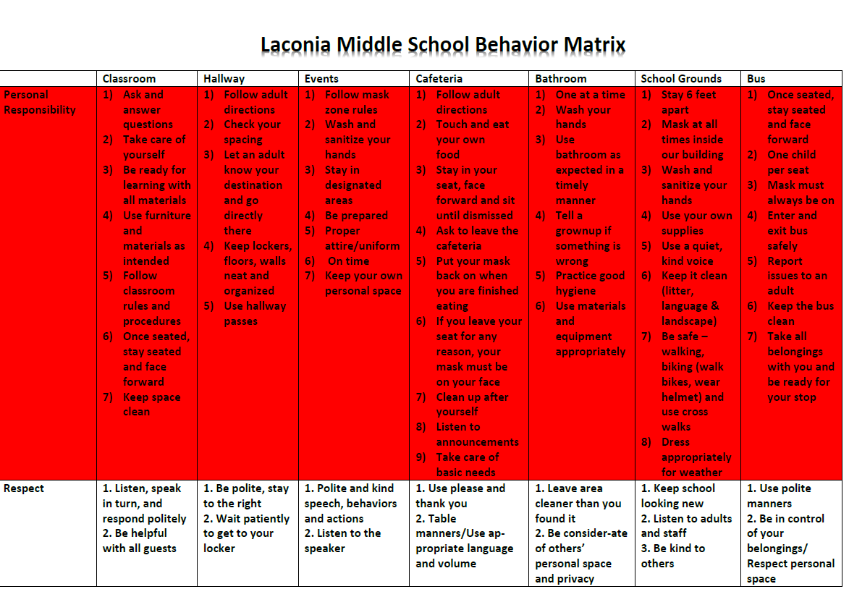
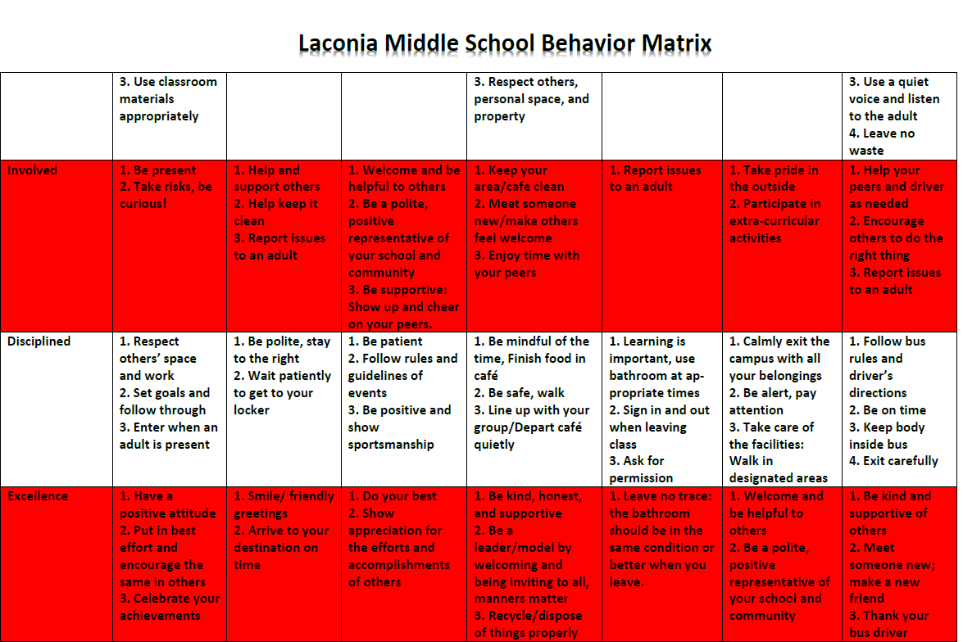
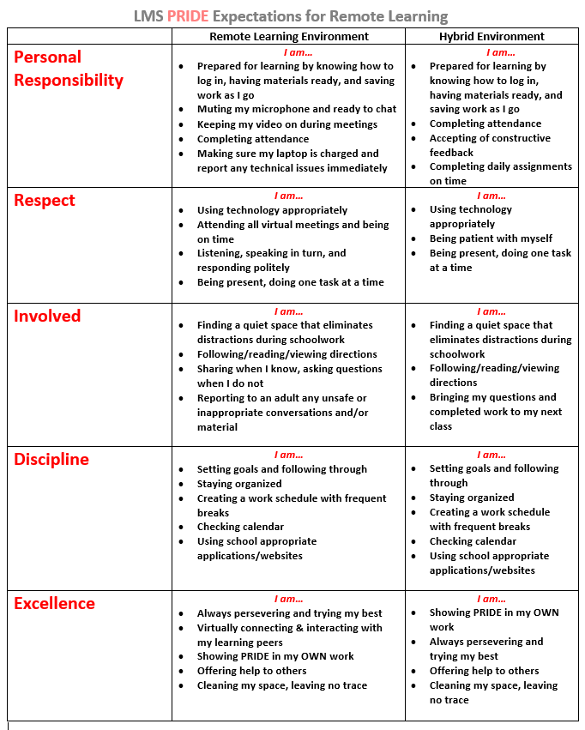

It is the belief of Laconia Middle School that whenever possible consequences for behavior and performance reflect the expectations of society. It is for this reason that LMS follows a progressive discipline philosophy and seeks natural or connected discipline whenever possible.
(Progressive discipline is the act of increasing consequences as the number of discipline referrals increases. This is especially true in the event of a recurring behavior.)

Students should practice self-discipline, self-control, and character building.
Behavior not conducive to the learning environment will not be tolerated.

DRESS CODE
Students are expected to adhere to standards of cleanliness and dress that are compatible with the requirement of a good school environment.

1. Students must wear attire which is not distracting, or does not promote weapons, the use of tobacco, alcohol, or illegal substances, and is not vulgar or profane. This includes sexual innuendos.
2. Halter tops, muscle shirts, short shorts and pajama bottoms are not allowed.
3. Clothing must cover the body from armpit to mid-thigh (undergarments must be fully covered.)
4. Clothing which exposes the belly, waist or cleavage is not allowed.
5. Pants that fall down without holding them up are not allowed.
6. Holes/rips in jeans above the mid-thigh are not allowed.
7. Cleats or spikes are not to be worn in the building.
8. Hats and hoods are not to be worn in school. They must remain off until you have exited the building for the day. There may be special days designated for hat days, which will be approved by the principal.
9. Chains or jewelry with spikes are not allowed.
10. Students should not have sunglasses, outerwear (at the discretion of administration) or gloves on unless given specific permission.

--Administration has the final say on all items of dress or accessories. --

Students not meeting the dress code will be asked to change whatever item(s) is inappropriate.
Parents may be called and asked to bring in clothes. Students unable to change their clothes will be in the SSR until they are able to obtain appropriate attire. Repeated violations will result in disciplinary action.

USE OF PERSONAL ELECTRONIC DEVICES

Cell phones -Must be turned off when entering the building in the morning and must remain off until 2:21pm. (Vibrate or silent is not acceptable)
-Cell phones must be locked in the student locker throughout the school day. During the 2020-2021 school year, cell phones will be turned off and stored in backpacks.
-Phones may only be used after the last bell unless specific permission is granted.
-Cell phones are the responsibility of the student to secure during the school day.
-Text messaging is not allowed during the school day.
-School phones may be used with teacher permission.
Recording devices are only allowed with teacher permission. Recording without permission will result in disciplinary action.
Cameras, including cell phone cameras, are not allowed to be used without consent of a teacher for educational purposes.
I-pods, MP3s, game boys, Apple watches, etc… should not be used during the school day unless specific teacher permission is given for a specific purpose.
Lasers and Laser pointers are not allowed at school by students. These must get picked up by a parent.
Students found with their cell phone or electronic device on, or are found using it during the school day, will have it taken by the staff. This can be picked up at the end of the day. All further offenses by the student will have the device taken away and picked up by a parent. Failure to comply with this will result in further disciplinary action. Cameras and other recording devices being used may be subject to further harassment complaints or legal action depending on how they are used.

General School and Cafeteria Rules/Consequences
Students are expected to display the specific cafeteria behaviors articulated in the Behavior Matrix (p. 21-22). Soda, coffee, and energy drinks and other caffeinated beverages are not to be consumed on school grounds by students unless pre-approved by administration. Food is not to be sold in school unless a fundraiser is cleared by administration.

Discipline and Remediation
The Laconia School Board expects students to contribute to a productive learning climate. Students who choose to not comply with the Laconia Middle School rules and procedures will face appropriate remedial and/or disciplinary consequences. The severity of consequences assigned by administration will vary depending on the nature/frequency of the infraction(s) under a progressive discipline model. Major infractions such as stealing, physical contact (including horseplay), insubordination, profanity, disrespect directed toward staff, skipping class, are examples of infractions that can lead up to and include suspension from school.

Minor infractions include: Non-compliance that does not cause a major disruption, minor physical contact, tardy to class (five minutes or less), other minor behaviors that take away from LMS PRIDE.

More serious major infractions that may require police notification in addition to remediation/ disciplinary consequences include: falsely calling 911, stealing, distribution of over the counter medication, leaving school without permission, possession of a lighter, lighting a lighter, damaging property, truancy.

Student Conduct

Consequences listed below are a starting point. Progressive discipline applies to all. Administration will have the final say.

-Be to class on time. Late to class will be a teacher detention. Skipping class is an after school administrative detention.
-Be in class, not leave class without permission. Leaving without permission is an after school detention (minimum).
-Not disrupt class or activity. Progressive discipline based on severity.
-Use appropriate language, not swear or display obscene gestures. Swearing in conversation is a teacher detention. Swearing at a peer is a minimum of two days’ detention. Additional action will take place if this is done in the form of bullying or harassment (see policy). Swearing at a staff member is an automatic suspension out of school.
-Be courteous, not show disrespect or defiance to a teacher. Administrative detention is the minimum consequence.
-Be honest, not lie or deceive. Teacher detention is the minimum consequence.
-Not cheat/plagiarize. Assignment must be redone, plus the teacher will call home.
-Put away technology, not use cell phones, mp3s/iPod, GameBoys, etc. These items should remain secure during the school day. Special permission may be granted for educational purposes. First offense: Staff will take the item for the rest of the day. Second offense: a parent will have to come in to pick up the item, third offense will result in parent pick up of item and progressive discipline.
-Not chew gum. Teacher detention for first offense.
-Respect the facility & equipment: Graffiti/marking school property, Misuse of bathroom, learning materials, or property of LMS. ISS and possible restitution is the minimum consequence.

-Falsely calling 911. Police notified. Out of School Suspension
-Harassment. Investigation. Policy followed (see page 27), police notified, Suspension
-Bullying. Investigation. Policy followed (see page 24), police notified, Suspension
-Trying to instigate a fight. In-school suspension.
-Stealing. Police notified. Suspension
-Distribution of over the counter medication. Police notified. Suspension.
-Leaving school without permission. Police notified. In-school suspension.
-Physical Contact. Including horseplay. In-school suspension or out of school suspension.
-Damaging another person’s property. Replace item. Progressive discipline followed.
-Possession of a lighter. Minimum In-School suspension.
-Lighting lighter- Minimum Out of School suspension. Possible police involvement.

Bullying and harassment follow Laconia School District policy JICK. (See section on bullying/harassment.)

Violence, weapons, and crime will not be tolerated on any Laconia School District property or at any Laconia School District sponsored events (RSA 193-D:1).

Students with the following behavior will have as a minimum consequence: Out of School Suspension, Parent needs to meet with the school, Police contacted. Additional options include: Required counseling, Community Service, Meeting with Superintendent of Schools, Brought in front of School Board for possible expulsion.

Tobacco and/or Tobacco Products/E-Cigarettes and/or Vaporizers Under RSA 78:12-C and Laconia School District Policy (JICG) no person under 18 years of age shall purchase, possess or use any tobacco product. Possession or use of tobacco products, electronic cigarettes, and/or vaporizers by any person is prohibited in Laconia Middle School buildings or on Laconia Middle School grounds at any time, which includes all school events that occur outside of the regular school day. Tobacco products that are seen will be confiscated and destroyed or turned over to the Laconia Police Department whether they are being used or not. Student possession or use of tobacco products will result in appropriate disciplinary action and police notification.

*Emergency conditions/fire alarm (any act that interferes with safety in an emergency or evacuation procedure or is a false alarm).
*Possession of weapon (facsimile or anything intended to be used as a weapon).
*Assault - verbal or physical threatening or intimidating.
*Battery - aggressive physical contact.
*Bomb threats.
*Fireworks (possession and or use).
*Chemical Weapons (e.g. pepper spray).
*Arson.
*Theft.
*Vandalism (any willful act of defacing, damaging or destroying school property or property belonging to another person; accidental damage to property that is not immediately reported to the office by the person causing such damage may also be considered vandalism).
*Possession, use of, or being under the influence of drugs, alcohol, or controlled substances including paraphernalia – (when a student is suspected of being under the influence of drugs or alcohol in school, there will be immediate parent contact).
*Distribution of prescriptions or non-prescription drugs
*Sales and/or soliciting of drugs

No student on OSS will be allowed on school district property (RSA 193-D:1 or be allowed to attend or participate in any school sponsored activity.

Students earning administrative detention, ISS or OSS during a dance week (Even if time served is the following week) will not be allowed to attend the dance.

SSR (Student Support Room)
The goal of SSR is to provide students a supportive environment in which to process behaviors which may be a distraction from the learning environment. Students will process with one of our behavior educators and develop a plan to address behaviors. The SSR program is facilitated by our behavior teacher.

Administrative Detention will begin at the conclusion of regular school hours and will run for 1 hour. Students may not use cell phones during detentions. Students need to bring work or a book to administrative detention. Skipping assigned administrative detention, or failure to complete administrative detention, will result in two additional administrative detentions. One may be served during lunch. A progressive discipline policy will apply.

OUT OF SCHOOL SUSPENSION

Students suspended from school are responsible for all missed assignments, test, and quizzes. Students will not be punished academically for earning an Out of School Suspension. Upon suspension, a “homework request” will be made by the Administrator’s office and given to the team of the student. Homework and assignments missed will be available for the parent or guardian to pick up the following school day. Students are responsible to turn in completed assignments upon their return to school. Work that is not complete will be a zero.

The administration of Laconia Middle School follows a progressive discipline policy. Students suspended due to repeated offenses or failure to follow through on assigned consequences, will be assigned additional OSS time.
Breakfast & Lunch Program

Food Service Department

Food Service
Applications for free or reduced price meals are available for any family who wishes to apply. Applications are sent to each household at the beginning of the school year and are available throughout the year at each school cafeteria, at the SAU office and online at www.laconiaschools.org/fservice. If your child received a benefit last year, they are entitled to the same benefit for the first 30 school days of the new year, or until a new application is submitted that changes the prior year’s status. If you qualify for free meals but choose to send lunch from home and only get milk at school, by regulation the milk is not free and must be purchased.

If anyone in your household receives SNAP (Food Stamps), you may automatically be qualified for free meals for the year via Direct Certification and do not need to complete an application. If you have any concerns or questions about this, please contact the Food Service Office.

Students having special dietary needs and requiring meal modification must have their physician complete a Special Diet Order. These are available in the nurse’s office, at the SAU office and online at www.laconiaschools.org/fservice.

Each student has an account in our Meal Time system from which meal and a la carte charges may be debited. Parents are encouraged to deposit several weeks of payments. Students can make deposits into their account during breakfast or lunch. Checks are welcome and we will gladly split the amount sent in among different family members if it is indicated on the envelope. Please note that the City of Laconia charges $25.00 for any bounced checks. It is imperative that you keep enough money in each student’s account to cover any charges that are incurred. Balances will move with each student as they move from grade to grade and school to school.

You can check account balances and student activity online free of charge by going to www.mymealtime.com and setting up an account using your student’s school ID. Online deposits using a credit or debit card can also be made at www.mymealtime.com. This is a great way to pay for multiple children at once, even if they are in different Laconia Schools. There is a $25 minimum, but this is per DEPOSIT, not student, meaning you can spread the $25 over several students if you wish. Meal prices can be found on each month’s menu or online at www.laconiaschools.org/fservice. Menus are sent home monthly and posted on our web site.

If you have any questions or comments on the Food Service program in your school, please contact the Food Service office at 524-3543 or food.service@laconiaschools.org. The district’s charging policy is available on the Food Service website at www.laconiafoodservices.weebly.com

Breakfast rules
All students going to the cafeteria in the morning must be there for the purpose of eating the breakfast meal. At all times, students must demonstrate proper conduct in the cafeteria. Failure to do so may lead to suspension from the cafeteria. The serving of breakfast will begin on the first day of school. Students are allotted 20 minutes maximum time to eat breakfast. Breakfast options may be limited for students tardy to breakfast. Breakfast is served from 7:15-7:45. The cafeteria closes at 7:50

Athletic and Extracurricular Programs

Student-Athletic
Interscholastic Sports Guidelines
Your son/daughter may be a candidate for the Laconia Middle School athletic teams and may be representing Laconia Middle School in regularly scheduled games or meets during the season.
Please read the Laconia School District Student and Parent Athletic Guide carefully. Students and parents must sign the contract on the last page in order to participate in any sport. This can be attained in the office or on the LHS or LMS websites. Any questions can be answered by the Coach, Athletic Director or Principal.

For updates/schedule changes, please be sure to check the school website or follow us on Twitter @LMSachems.

Athletes are not to loiter after school waiting for practice. They must be with their coach, a teacher, or leave school and return. Athletes are recommended to lock all personal items in a gym locker. The school is not responsible for lost or stolen items.
Uniforms are the responsibility of the athlete. Damaged, lost, or stolen equipment/uniforms will be the responsibility of the parent to replace or pay for.

Physical Examination
In order to participate in athletics at LMS a physical exam must take place and be on file with the school nurse. This is required to be done only once over the course of an athlete’s middle school years.
In order to participate in any sport at LMS a signed Sports Health Record form must be presented to the coach on the first day of practice or tryouts. Without this form an athlete will NOT be allowed to participate. This must be done for EVERY sport an athlete participates in. This form is available in the main office or on the LMS website.

REAL Initiative at LMS

REAL Initiative supports a variety of expanded learning opportunities at LMS each year and is open to all students at LMS. Over the course of the school year REAL will support student tutoring, summer learning programs, enrichment activities and specific teacher driven learning opportunities. Look for more detailed information on Laconia Middle School and Laconia School District website.

Other school opportunities that meet at various times include Student Council, Math Teams, & Yearbook.

National Junior Honor Society
Students will be invited to apply based on high academic standing. This is done in the springtime. Student applications will be brought to the NJHS committee without student names attached. A vigorous process looking at involvement in the school, community, role model behavior and contributions to society will be looked at. The NJHS is comprised of leaders and does a great deal of community service.

Student Council
The student council at Laconia Middle School is made up of representatives from grades 6, 7, and 8. Student homeroom representatives will serve on the student council. The purposes of this organization are as follows: encouraging good community, student/faculty relationships, providing for student expression on school activities and promoting the general welfare of the school.

Social Activities
Dances and other social events are planned for each academic year. Students will be notified of upcoming activities at appropriate times throughout the year.

Eligibility and Participation Policy
In order to participate in extracurricular/athletics at LMS a student must not fail two classes and have good attendance. Activities and programs will be defined as any event taking place outside the school or regular school day. A student must be in school for ½ the day in order to participate in an activity for that day. Exceptions must be presented in writing to the Administration.
.
LMS PTO
LMS PTO meets monthly at an allotted time in the school Library. Our meetings are open to all families and staff of LMS. The purpose of LMS PTO is to provide information on school programs, opportunities for parent education, enhance learning and education objectives, support staff, provide volunteers for activities and fundraise. Please join us for our meetings as we continue to share ideas and support our school.
School Safety

Hazardous Materials
Information about the potential adverse health effects of lead or chemicals may be found in the nurse’s office or with the facility manager.

Fire Drills/Evacuation Drills/ALICE Drills
Periodic fire drills in all schools are required by law. It is necessary that pupils be familiar with procedures and exits for each of their classrooms. Our school fire alarm system is a series of short blasts on the alarm system. In leaving the room, students are expected to be quiet, follow the teachers’ directions and walk to the designated area. Fire drill instructions are posted in each room. Students will:
a) listen for directions while passing, or waiting in designated area.
b) stay to the right while exiting the building.
c) walk in orderly fashion.
d) remain with that group outside of building following teacher’s instructions.

Other Emergency Drills will be conducted throughout the school year. Other drills may include: Intruder, shelter in place, duck and cover, reverse evacuation)
*****In the event of a lockdown or a secure campus parents or other visitors will not be allowed to enter or exit the school (this includes picking up or dismissing of students) *****
Communication with families will occur using the alert system.

Building Security
The school building is secured with exterior doors which are locked from the outside during the day. This prevents any unwanted visitors entering unnoticed. The main office door is equipped with a page and buzzer system. Visitors will be required to press the call button. Office staff will then press the “door release” button. All visitors will be issued a pass from the main office. A security system may be video and audio taping people in the halls and movement outside the building.

Emergency/Family Resource Numbers

Here is a list of community resources available to families in need.

FIRE, ACCIDENT, OR NEED AMUBLANCE - 911
- Adams, Eric LPD, Prevention, Enforcement, and Treatment Coordinator – 524-5257 ext. 356
- Al-Anon - 524-1854 (help with alcohol/drug abuse)
- Bulimia-Anorexia Hot Line - 1-800-342-6486 (help with eating disorders)
- Child and Family Services – 524-5835
- Crisis Pregnancy Center – 528-3121 (questions about pregnancy)
- Genesis Behavioral Health – 524-1100
- Information and Referral – 1-800-352-3311 (assistance with who to call for help)
- Laconia Police Department – 524-5257
- Lakes Region Community Services – 524-8811
- National Center for Missing Children – 1-800-843-5678
- National Runaway Switchboard – 1-800-621-4000
- NH Poison Control – 1-800-222-1222
- Quit Smoking – 1-800-4-CANCER
- Sexually Transmitted Disease Hot Line – 1-800-852-3345

District Policy

No School/Delayed Opening
The Laconia School District will be utilizing an Emergency Notification System for school cancellations and other important information. Up to date phone numbers are necessary for this system to work. Cancellations can also be found on local radio and TV stations.

Non-Discrimination
The Laconia School Board and the city schools do not discriminate in the administration of our educational programs, activities, or employment practices on the basis of race, color, national origin, age, gender, handicap, disability, sexual orientation, marital status, or pregnancy. This statement is a reflection of the mission of the Laconia School District and refers to, but is not limited to, the provisions of the following laws:
• Title VI and VII of the Civil Rights Act of 1964
• The Age Discrimination Act of 1967
• Title IX of the Education Amendment of 1972
• Section 504 of the Rehabilitation Act of 1973
• The Americans with Disabilities Act of 1975
• NH Law Against Discrimination (RSA 354-A)
• State Rule: ED. 303.01(i),(j),(k)

Pursuant to RSA 354-A:27-28, during the 2019-2020 school year, the Laconia School District convened a Diversity and Inclusion Task Force of stakeholders to oversee the development and implementation of a coordinated plan to prevent, assess the presence of, intervene in, and respond to incidents of discrimination on the basis of age, sex, gender identity, sexual orientation, race, color, marital status, family status, disability, religion, creed, national origin, or pregnancy, all as defined in RSA 354-A. This Task Force shall commence in November 2019 and convene no less than bi-monthly of every two months.

Any person having inquiries concerning Laconia School District’s compliance with regulations implementing these laws may contact: Superintendent of Schools, School Administrative Unit #30, 39 Harvard Street, Laconia, New Hampshire 03246 telephone number (603) 524-5710. The Title IX Coordinator Information is located at the Superintendent’s office. The Regional Director (federal law office) is located at: Office of Civil Rights, US Department of Education, J.W. McCormack Building, PO & Courthouse, Room 222, 01-0061, Boston, MA 02109 (617) 223-9662, TDD (617) 223-9695. The Equal Opportunity Commission is located at JFK Federal Building, Room 475, Government Center, Boston, MA 02201 (617) 565-3200. The NH Commissioner for Human Rights is 2 Chenell Drive, Concord, NH 03301 (603) 271-2767.

STUDENTS WITH DISABILITIES
The Laconia School District shall provide a free appropriate public education and necessary related services to all children with disabilities residing within the district, required under the Individual with Disabilities Act and New Hampshire Law. It is the intent of the district to ensure that students who are disabled within the definition of Section 504 of the Rehabilitation Act of 1973 are identified, evaluated and provided with appropriate education services. Student may be disabled within the meaning of Section 504 of the Rehabilitation Act even though they do not require services pursuant to the IDEA. For students eligible for program under IDEA, the district shall follow procedures for referral, identification, evaluation, placement, and delivery of services to children with disabilities provided in federal and state statutes, which govern special education. For those students who are not eligible for services under IDEA, but because of a qualifying disability as defined by Section 504 of the Rehabilitation Act of 1973, need or are believed to need special education or related service, shall establish and implement a system of procedural safeguards. The safeguards shall cover students’ identification, evaluation, education safeguards and procedural placement. This system shall include notice, and opportunity for the student’s parent(s) guardian(s) to examine relevant records, and impartial hearing with opportunity for participation by the student’s parent(s)/guardian(s) and representation by counsel, the right to be represented by legal counsel and review procedure. The Laconia School District recognizes its obligation to provide an education for all students determined to be educationally disabled and in need of special education and related services. This obligation shall begin when a student reaches three years of age and shall continue until the student’s 21st birthday or until such time as he/she receives a high school diploma, whichever occurs first, or until the child’s Individualized Education Program(IEP) team determines that the child no longer requires special education in accordance with federal and state law.

For more information about the policies, procedures and services established in your school district for special education, the SAU #30 SPECIAL EDUCATION PLAN is available for review at the Superintendent’s office.

NOTIFICATION OF RIGHTS UNDER FERPA
The Family Educational Rights and Privacy Act (FERPA) afford parents and students over 18 years of age (“eligibility students”) certain rights with respect to the student’s education records:
The right to inspect and review the student’s education records within 45 days of the day the District receives a request for access. Parents or eligible students should submit to the Principal or his designee a written request that identifies the records they wish to inspect. The Principal or his/her designee will make arrangements for access and notify the parent or eligible student of the time and place where the records may be inspected.
The right to request an amendment to the student’s educational records, which the parent or eligible student believes are inaccurate or misleading. Parents or eligible students may ask Laconia School District to amend a record generated by the Laconia School District that they believe is inaccurate or misleading. They should write the Principal or his/her designee, clearly identify the part of the record they want changed, and specify why it is inaccurate or misleading.
If the Laconia School District decides not to amend the record as requested by the parent or eligible student, the School District will notify the parent or eligible student of the decision and advise them of their right to a hearing regarding the eligible student when notified of the right to a hearing.
The right to consent to disclosure of personally identifiable information contained in the student’s education records, except to the extent that FERPA authorizes disclosure without consent. One exception, which permits disclosure without consent, is disclosure to school officials with legitimate educational interests. A school official is a person employed by the Laconia School District as an administrator, supervisor, instructor or support staff member (including health or medical staff and law enforcement personnel); a person serving on the Laconia School District School Board; a person or company with whom the Laconia School District has contracted to perform a special task (such as an attorney, auditor, consultant, expert, or therapist); a parent or student serving on an official committee, such as a disciplinary or grievance committee or assisting another school official in performing his or her tasks; or the Laconia School District’s insurance carrier.
A school official has a legitimate educational interest if the official needs to review an education record in order to fulfill his or her professional responsibility. Upon request, the Laconia School District discloses education records without consent to officials of a school district in which a student seeks or intends to enroll.
The right to file a complaint with the U.S. Department of Education concerning alleged failures by the District to comply with the requirements of FERPA contact:
Family Policy Compliance Office
U.S. Department of Education
600 Independent Avenue SW
Washington, DC 20202-460

PUPIL SAFETY AND VIOLENCE PREVENTION POLICY BULLYING
- General Statement of Policy
All pupils have the right to attend school and school-sponsored activities that are safe, secure and peaceful environments. Pupils should be protected from all forms of physical, emotional and psychological bullying and cyber-bullying. Bullying in schools has historically included actions shown to be motivated by a pupil’s actual or perceived race, color, religion, national origin, ancestry or ethnicity, sexual orientation, socioeconomic status, age, physical, mental, emotional or learning disability, gender, gender identity and expression, obesity, or other distinguishing personal characteristics, or based on association with any person identified in any of the above categories.
It is the intent of this policy to protect pupils from physical, emotional and psychological harm by addressing bullying and cyber-bullying of any kind in our district/school, and to prevent the creation of a hostile educational environment. All pupils are protected under this policy, regardless of their legal status. While this policy applies to pupils only, school district employees, regular school volunteers, coaches, and persons who have contact with pupils in connection with school classes, activities and programs have responsibilities for reporting incidents of bullying to school administration. Bullying and cyber-bullying outside of school activities or off school premises is subject to this policy as set forth herein.
II. Bullying, Cyber-bullying and Retaliation Prohibited
It shall be a violation of this policy to engage in, or influence others to engage in, the bullying or cyberbullying of a pupil. It shall be a violation of this policy to engage in retaliation or false accusations against a victim, witness or anyone else who in good faith provides information about an act of bullying or cyberbullying. There shall be disciplinary consequences or remediation or both for a person who commits an act of bullying or cyber-bullying, falsely accuses another of the same as a means of retaliation or reprisal, or otherwise violates this policy.
III. Definitions
Bullying means a single significant incident or a pattern of incidents, involving a written, verbal or electronic communication or a physical act or gesture or any combination thereof, directed at another pupil which:
1. physically harms a pupil or damages the pupil’s property;
2. causes emotional distress to a pupil;
3. interferes with a pupil’s educational opportunities;
4. creates a hostile educational environment; or
5. substantially disrupts the orderly operation of the school.

Bullying shall include actions motivated by an imbalance of power based on a pupil’s actual or perceived personal characteristics, behaviors, or beliefs, or motivated by the pupil’s association with another person and based on the other person’s characteristics, behaviors, or beliefs.

Cyber-bullying means bullying undertaken through the use of electronic devices. Electronic devices include, but are not limited to, telephones, cellular phones, computers, pagers, electronic mail, instant messaging, text messaging and websites. Perpetrator means a pupil who engages in bullying or cyber-bullying. School property means all real property and all physical plant and equipment used for school purposes, including public or private school buses or vans. Victim means a pupil against whom bullying or cyber-bullying has been perpetrated. IV. Actionable Incidents of Bullying or Cyber-bullying Bullying” or cyber-bullying shall occur when an action or communication as defined in the above “definitions” section: 1. Occurs on, or is delivered to, school property or a school-sponsored activity or event, on or off school property; or 2. Occurs off of school property or outside of a school-sponsored activity or event, if the conduct interferes with a pupil’s educational opportunities or substantially disrupts the orderly operations of the school or school-sponsored activity or event. V. Reporting Procedures A pupil may report bullying or cyber-bullying to any school district employee or agent. Any school employee or contracted agent, who receives a complaint of bullying or cyber-bullying or is otherwise aware of such conduct, must immediately report it to the principal. The principal or a designee must report the incident to the parents or guardians of both the alleged victim and perpetrator within 48 hours of the report, and in a manner that protects the child’s privacy rights, unless the superintendent grants the principal or his designee a parental notification waiver in writing after determining that a waiver is in the best interests of either the alleged victim or perpetrator. The principal or designee must promptly report all substantiated incidents of bullying or cyber-bullying to the superintendent or designee. The principal or designee shall provide a written communication to the parents or guardians of the victim and perpetrator of confirmed bullying incidents regarding the school’s remedies and actions within the boundaries of applicable law. The principal or designee shall provide an oral communication to the parents or guardians of students involved in alleged bullying cases not substantiated. The school district shall annually report substantiated incidents of bullying or cyber-bullying to the Department of Education using the Department’s standard form. Such reports shall not contain any personally identifiable information pertaining to any pupil. Laconia School District Policy JICK Also GBAAA Page 3 of 3 VI. Investigation The principal or designee must initiate an investigation within five (5) school days of the reported incident of bullying or cyber-bullying. The investigation shall be completed within ten (10) school days of the reported incident, and should include speaking with the alleged victim, alleged perpetrator, known witnesses and reviewing other evidence available through reasonable good faith efforts. The results of the investigation shall be documented in writing and preserved in accordance with laws governing retention of educational records. The superintendent or designee may grant in writing an extension of the time period for the investigation and documentation of reports for up to an additional seven (7) school days, if necessary. The superintendent or superintendent’s designee shall notify in writing all parties involved of the granting of an extension. VII. Appeals A parent or guardian who is aggrieved by the investigative determination letter by the principal or his/her designee may appeal the determination to the Superintendent for review. The appeal shall be in writing addressed to the Superintendent, shall state the reason(s) why the appealing party is aggrieved, and the nature of the relief they seek. The Superintendent shall not be required to re-investigate the matter and shall conduct such review as he/she deems appropriate under the circumstances. It is in the best interests of students, families and the District that these matters be promptly resolved. Therefore, any such appeal to the Superintendent shall be made within ten (10) calendar days of the parent/guardian’s receipt of the investigative determination letter of the principal or his/her designee. The Superintendent shall issue his/her decision in writing. If the parent or guardian is aggrieved by the decision of the Superintendent, they may appeal the decision of the School Board within ten (10) calendar days of the date of the parent/guardian’s receipt of the Superintendent’s decision. An appeal to the Superintendent shall be a prerequisite to any appeal to the School Board. The appeal to the School Board shall be in writing, addressed to the School Board Chair, in care of the Superintendent, shall state the reason(s) why the appealing party is aggrieved, and the nature of the relief they seek. An aggrieved parent/guardian has the right to appeal the final decision of the local School Board to the State Board within thirty (30) calendar days of receipt of the written decision of the local School Board in accordance with RSA 541-A and State of New Hampshire Department of Education Regulations set forth in ED 200. The State Board may waive the thirty-day requirement for good cause shown, including, but not limited to, illness, accident, or death of a family member. VIII. Training The school district shall provide annual training for school employees, regular school volunteers or employees of a company under contract to a school or school district who have significant contact with pupils for the purpose of preventing, identifying, responding to and reporting incidents of bullying or cyberbullying. Laconia School District Policy The school district shall provide educational programs for pupils and parents in preventing, identifying, responding to and reporting incidents of bullying or cyber-bullying. Programs for pupils shall be written and presented in age appropriate language IX. Use of Video or Audio Recordings in Student Discipline Matters The District reserves the right to use audio and/or video recording devices on District property (including school buses) to ensure the health, safety, and welfare of all staff, students and visitors. Placement and location of such devices will be established in accordance with provisions of Policies EEAA, EEAE, and ECAF. In the event and audio or video recording is used as part of a student discipline proceeding, such video may become part of a student’s education record. If an audio or video does become part of a student’s education record, the provisions of Policy JRA shall apply. The Superintendent is authorized to contact the District’s attorney for a full legal opinion relative in the event of such an occurrence. X. Notice of Policy This policy shall be provided to school employees, regular school volunteers, pupils, parents, legal guardians or employees of a company under contract through handbooks and website posting.
Adopted: July 3, 2001 Revised: August 4, 2004, June 15, 2010, January 4, 2011, June 5, 2018

LACONIA SCHOOL DISTRICT HARASSMENT STATEMENT

The Laconia School District has an obligation to provide a safe environment for its students and employees based on mutual respect and understanding where the value of diversity is understood, individual differences are appreciated and where discrimination and harassment are not tolerated. The focus of the school district’s policy is prevention, intervention, documentation, and the use of good judgment and common sense.

Harassment

Harassment refers to any conduct which has the purpose or effect of substantially interfering with an individual’s academic/work performance, social performance, social development, or emotional stability by creating an intimidating, hostile, or offensive school/work environment. Teasing, threats, inappropriate physical contact, coercion, spreading false or malicious rumors or gossips, pranks, tampering with personal property, or similar behaviors are considered harassment and will be dealt with in accordance with established disciplinary procedures. Each allegation of harassment reported will be investigated by the administration and fully documented. Disciplinary action for students may include suspensions and/or referral to appropriate authorities. Discipline for adults may include actions up to and including discharge and/or referral to appropriate authorities.

Sexual Harassment

Laconia School District defines sexual harassment as unwanted or unwelcome or unsolicited sexual behavior. Sexual harassment includes but is not limited to: sexual gestures and comments directed toward or reference to another person; inappropriate touching, grabbing or pinching; sexual graffiti directed toward another person; giving or showing a person offensive sexual material; sexual gossip or remarks which affects a person’s ability to function in the school environment peacefully; and any other type of unwanted sexual contact. Laconia School District will not tolerate these behaviors. Each allegation of sexual harassment reported will be investigated by the administration, fully documented, and dealt with appropriately in accordance with established disciplinary procedures. Disciplinary action for students may include suspensions and/or referral to appropriate authorities. Discipline for adults may include actions up to and including discharge and/or referral to appropriate authorities.

Notification

Policies regarding harassment in any form will be explained to all students and employees at the beginning of each school year and more frequently as deemed necessary by staff and administration. In addition, all such policies will be published annually in the student handbook and faculty handbook. The school district’s Title IX Director will be available to staff, students, and parents to explain harassment policies as necessary.

Investigation

All complaints deserve a prompt and thorough investigation by a person(s) responsible to act. Students should look to any adult to make a complaint - teachers, guidance counselors, nurses, secretaries, and/or administrators. The adults will then refer all student complaints directly to the appropriate administrator in their building or at the SAU level. Investigators will be as thorough and confidential as possible. Faculty and staff complaints will be processed through the title IX procedures. In all cases, retaliations of any kind against any person involved in the complaint process are prohibited.

DISABILITY ACCESSIBILITY
Laconia Middle School is a modern facility completed in 2009 and meeting all accessibility codes. Parking for persons with a disability is located near the loop in the front of the building.
Students with temporary conditions (i.e. on crutches) can get an elevator pass from the nurse.
Individuals who have accessibility problems or hearing impairments will be accommodated in all middle school activities provided the building principal is notified of specific needs at least one week prior to any event or activity.

